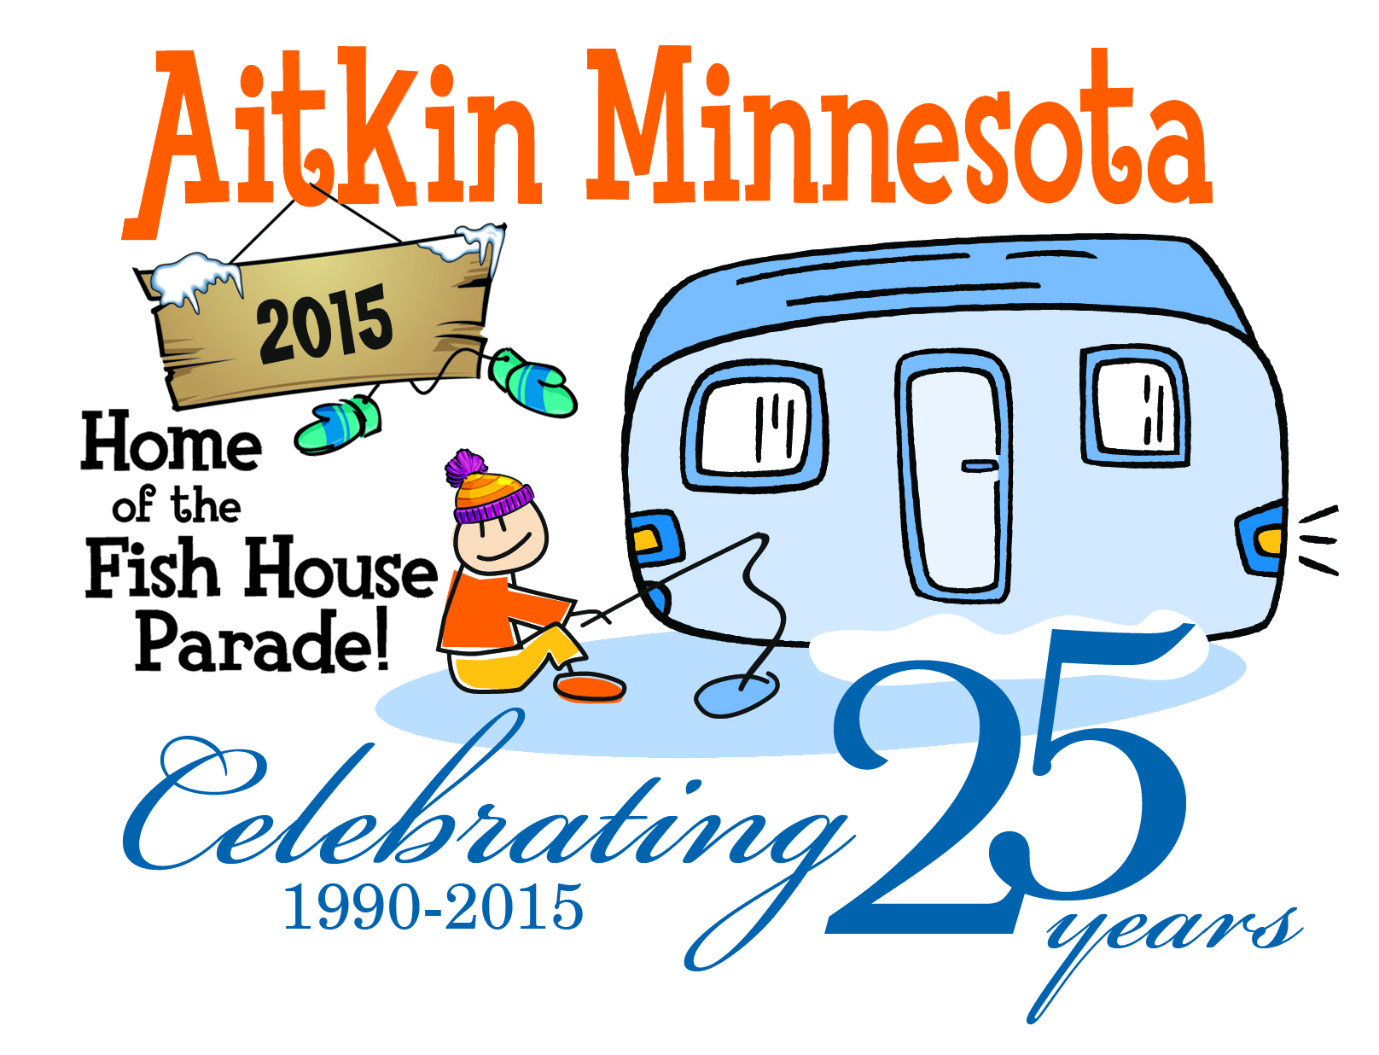
Sponsorship Opportunities
___________________________________________________________________
Platinum “Ice Palace” Level - $725.00
Platinum sponsors will receive:
Logo/Name recognition on ALL advertising pieces (print and radio)
Banner on the FHP Chamber Float
Logo on the Fish House 5k T-shirts
Name recognition during the parade & awards

Silver “Shanty” Level - $525.00
Silver sponsors will receive:
Logo/Name recognition on all advertising pieces (print and radio)
Logo on the Fish House 5k T-shirts
Name recognition during the parade & awards

Pewter “Portable” Level - $225.00
Pewter sponsors will receive:
Name recognition on all print advertising pieces
Name recognition during the parade and awards

Bronze “Warm Boots” level - $125.00
Bronze sponsors will receive:
Name recognition on all print advertising pieces

Yes – we want to sponsor the World Famous Fish House Parade
Business Name_______________________________________________________
Address/phone_______________________________________________________
Sponsorship level_____________________________________________________

Make Check payable to the Aitkin Chamber of Commerce and mail to P.O. Box 127, Aitkin, MN 56431. E-Mail logo information to upnorth@aitkin.com. Donation and Sponsorships should be
submitted by November 13th to ensure logo placement in ads. Thank You!

